## The Six Distance Markers (part 1)

### Distance Marker

The Distance Marker calculates one distance.

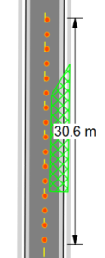

The_Distance_Marker_Tool

### Combined Distance Marker

This tool does the same as the Distance Marker but with the ability to show multiple distances as shown below.

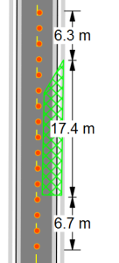

The_Combined_Distance_Marker_Tool

**To place a Combined Distance Marker:**

* Select the **Combined Distance Marker** tool from the Marker tab in the Tools Palette.
* Left click once to start drawing the distance marker, left click again to end the first distance marker and start the second
* Repeat this until you have all of your distances marked for that marker
* Right click to finish

### Offset Distance Marker

This tool allows you to un-clutter items on your plan by being “offset” from its true location.

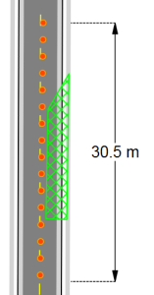

The_Offset_Distance_Marker_Tool

**To place an Offset Distance Marker:**

* Select the **Offset Distance Marker** tool from the Marker tab in the Tools Palette.
* Click once to start drawing the distance marker, click a second time to mark the end point.
* Drag your mouse laterally away from the distance marker to set the offset. Click a third time to finish drawing the marker.